Volunteering at Venture Arts

About Us and What We Do
Venture Arts is an award-winning visual arts organisation working with learning disabled artists. Through our studio programmes, exhibitions and collaborative projects, we remove barriers to the arts, we put artists in the lead, we champion neurodiversity and provide pathways for every individual to develop their creative identity.
Venture Arts equips people to succeed as artists, advocates, cultural workers, educators, curators and critics.
Each year the Venture Arts team mentor over 200 artists across a wide range of specialisms. Collaborations and partnerships are integral to what we do. Our studio artists exhibit regionally, nationally and internationally, and work is represented in collections worldwide.
We develop young artists through our Young People’s Art Club and school projects, and our ground-breaking Cultural Enrichment Programme of placements in galleries, museums, cultural venues and festivals increases representation and makes our cultural sector a fairer, more equitable place.

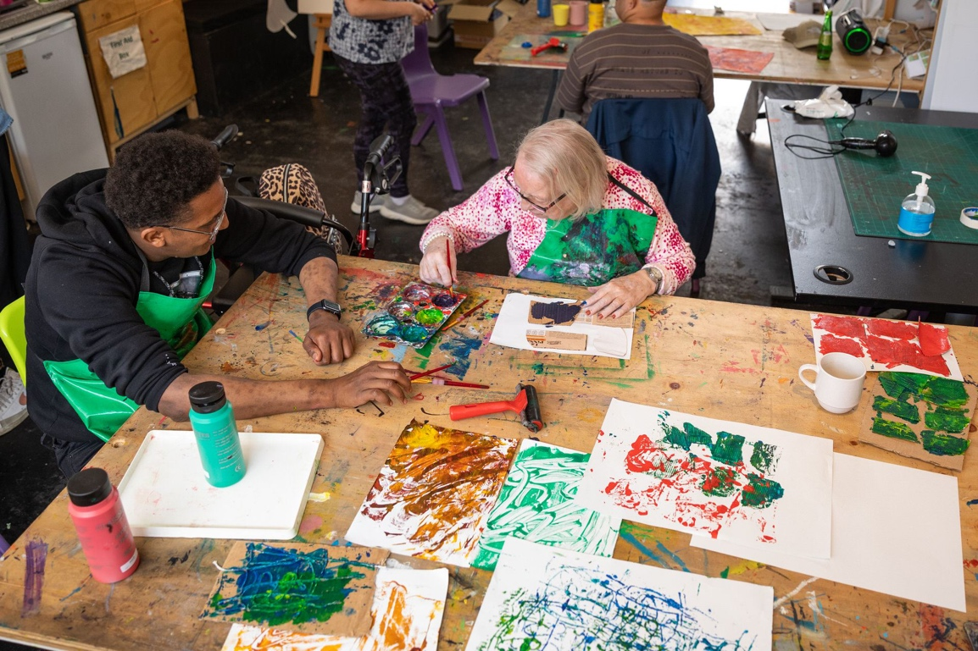

Volunteering in the Studio
Our accessible art studio is based in Hulme, close to Manchester city centre. The studio has a welcoming and social atmosphere and is a stimulating place to learn and develop artistic skills, including painting, illustration, animation, photography, ceramics and textiles.

Our artists are supported by our team of professional artist facilitators who nurture creativity and support the development of unique artistic identity. Artists mainly work on individual pieces of artwork and they occasionally go on trips to inform their practice. There are also opportunities for artists to take part in collaborative art projects which respond to specific themes.

We support the following visual art mediums:

- photography and moving image
- ceramics
- printmaking
- animation and illustration
- textiles
- painting
- we also deliver Bronze and Silver Arts Awards

Studio Timetable
Studio sessions take place as below:

- Adults aged 18+ run on a Monday to Friday from 10am-12pm and from 1-3pm.
- Young People’s Art Club (8-18 years) runs on a Wednesday 3:30-6pm and Saturday 10am-12:30pm
- Young People’s Art Club (18-25 years) runs on Thursday 1-3pm, and Friday 1-3pm
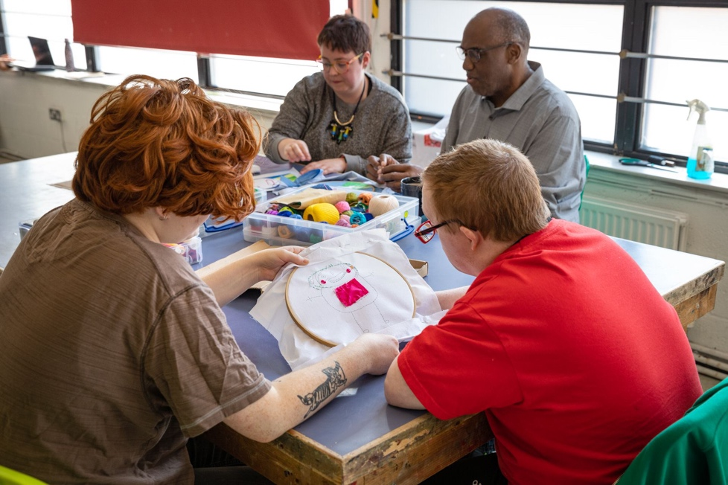

The Volunteer Role
Volunteers mainly offer support within our studio space and assist our facilitators in the studio environment. Following the guidance of the artist facilitators, volunteers offer verbal and hands-on support where needed to assist learning disabled artists. In doing so they support the development of creative skills, confidence and social interaction.

Volunteers also support on trips to arts and cultural venues.

Our volunteers come from lots of diverse backgrounds including student, professional and creative. They choose to give their time to Venture Arts for many different reasons, whether that be to spend time doing something enjoyable and supporting others in the community, to gain experience in the arts, social care, psychology, education and health, or as part of university placements and volunteering schemes.

Skills Required to Volunteer:
- good communication
- patience
- enthusiasm
- flexibility
- punctuality

Volunteers are not required to have a background in art but this can sometimes be preferable depending on the sessions. For example, the photography and moving image sessions use Photoshop and Procreate programmes, so knowledge of these is a bonus.

We ask our volunteers to commit to a minimal of 10 weeks, assisting in one two-hour session per week. Where there is capacity, volunteers can also increase their commitment and volunteer on more than one session. Volunteers assist within the same workshop each week to maintain consistency and development of work.

Volunteers receive a full induction including safeguarding training and a health and safety induction. All volunteers are required to undertake an enhanced DBS check upon joining the team.

Volunteers are entitled to claim £5.50 per session for travel expenses, and up to £4 for food expenses if they are with us for a full day. Volunteers can receive a full character reference upon completion of 10 weeks volunteering for us, which is available up to 30 months after finishing volunteering with us.

Placements
We also welcome applications throughout the year from students undertaking placements as part of their academic programmes. We regularly host placement students from Manchester and Salford based universities and colleges, but have worked with students on placements from far and wide, including Huddersfield, Derby, Leeds, Japan, China, Nigeria, India, France and Germany.

Other Volunteering Opportunities
As well as assisting within the studio environment volunteers can also help us with other activities and opportunities.
Other volunteering roles include:

- Events and exhibition assistance
- Admin assistance
- Artwork editing and design

When volunteering at events and exhibitions, roles may include helping with the set-up, offering drinks, signing people in, helping as a runner, helping pack down and tidy up afterwards.

From time-to-time, we welcome volunteers who wish to help in more of an administrative role, assisting at reception. This may include tasks such as answering calls, updating spreadsheets, managing stock or preparing documents.

Volunteers can also help with artwork editing, which involves using Photoshop to edit the artist’s work and adapt this into different formats for online and printing purposes.
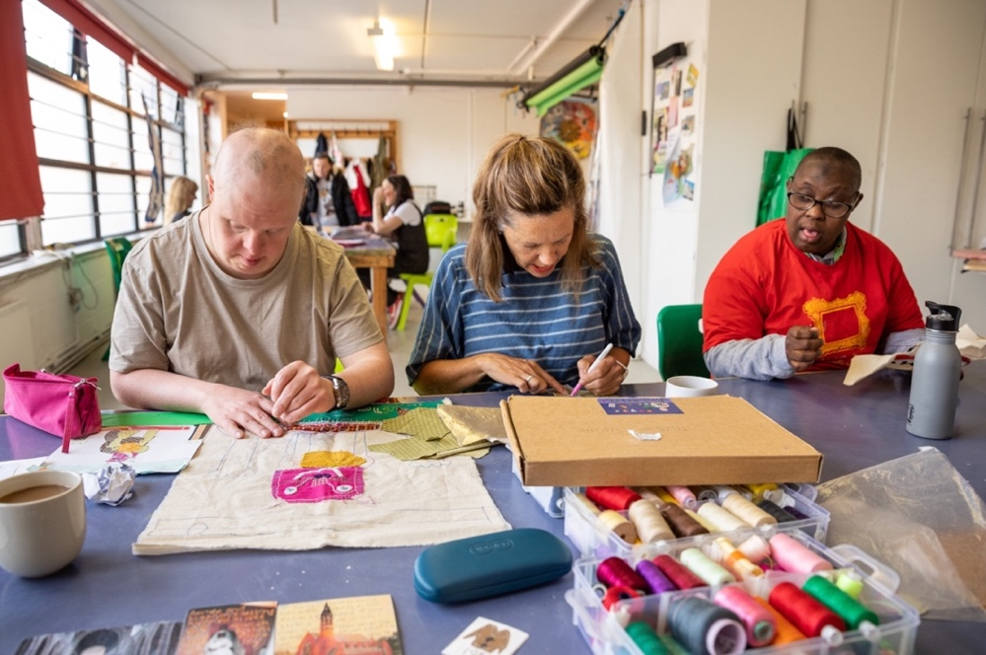

We are immensely grateful to people who volunteer their time to support us. Our studio is a more vibrant, productive, friendly and buzzing place thanks to the wonderful contributions of our volunteers.

What our volunteers say:
“I have been volunteering at Venture for around four years and it has helped me with my confidence… and also in my artwork. From day one… it feels like a family, helping artists develop their skills as well as creating a place where they feel at home.” - Louie

“I love volunteering at Venture Arts, it's such a great atmosphere and everybody is really kind. It's so fulfilling getting to help out, and doing so through creative workshops means it's always fun!” - Charlie

“Talented artists and friendly staff ensure Venture Arts is an inspiring place to volunteer. I have assisted with design, textiles, ceramics and photography projects which have enriched my placement year beyond my expectations.” - Sarah

Applying to Volunteer at Venture Arts
If you are interested in volunteering at Venture Arts, please download an application form from our website.

If you would like to discuss volunteering in more detail, please contact domino@venturearts.org or ring 0161 232 1223

